House Diary: a Digital Home Data Monitoring and Visualization System

Yebai Zhao

Rochester Institute of Technology, NY

Yz9422@g.rit.edu

Ziyan Huang

Rochester Institute of Technology, NY

zh9842@g.rit.edu

# Problem Definition

With the development of modern computer technology, people nowadays have unprecedented number of choices to gather the information created by the actions inside or around their houses, such as video recording, motion detecting, temperature or sound monitoring. While many smart home monitoring systems are able to record and store the data under time sequence, most of them keep the data separately. This makes people in the house less likely to review the data, since it consumes much time and effort. Smart video cameras can store the surveillance video continuously, but people might not willing to watch the content, and research also indicates that people might feel uncomfortable to have all their movement at home recorded. If users purely want to know whether their family members or pets were at home at a certain time, motion sensors might more favorable than cameras.

Other types of information, such as the sound, light, temperature or power consumption of a house, are rarely tracked based on the time. Although they are less expressive than the video footage, combining and comparing different types of data might be enlightening and interesting to common people, as that can be seen as the life log of the house. However, it is hard to find an implementation that successfully visualized those data in common houses. It can be intriguing if a device can blend in the household environment and visualize information from multiple source in the house in an artistic way.

Motion detectors can be used not only as a way to detect intruders of the house, it can also be used to track the movement status of the residents. As we known that sitting in front of the computer or TV are usually not healthy for people, it is possible that motion detectors can track residents’ motion in the room and notify them when they have sat too long.

# Related research

Combining different sensors in surveillance has become an evolving research area [2]. Johns Hopkins provided a method to design such multimedia surveillance system, which addressed the problem related to deployment of multiple sensors [3]. Efforts were also made to address the issue about coordination of multiple video camera. However, less researches explore dimensions of the representation of surveillance data around the house. Eun Kyoung Choe and Sunny Consolvo, demonstrated that people would not want to be recorded at home through an anonymous survey. This indicates the importance of the use of sensors and the approach of data visualization.

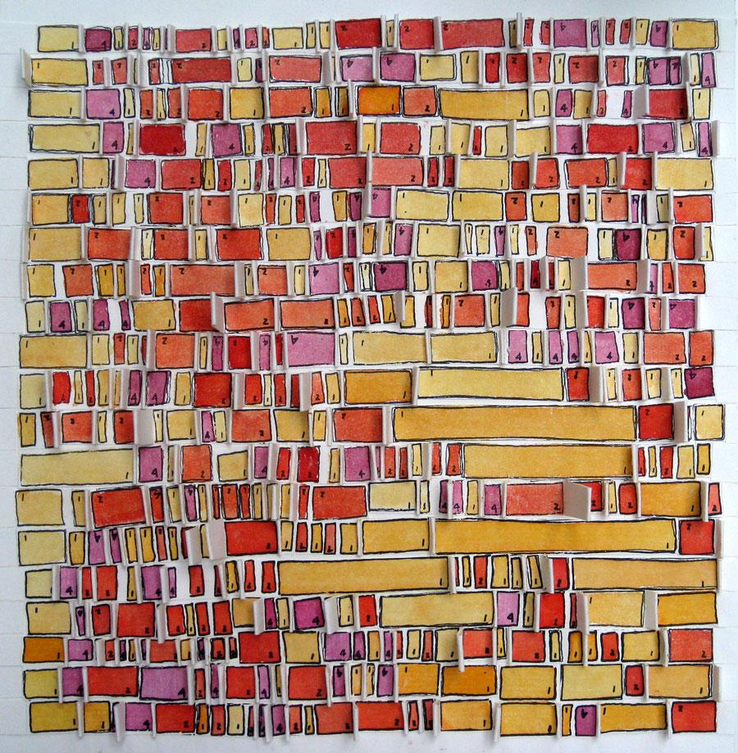

Figure . Laurie Frick's Pokey Red is a physical visualization of sleep data over a month

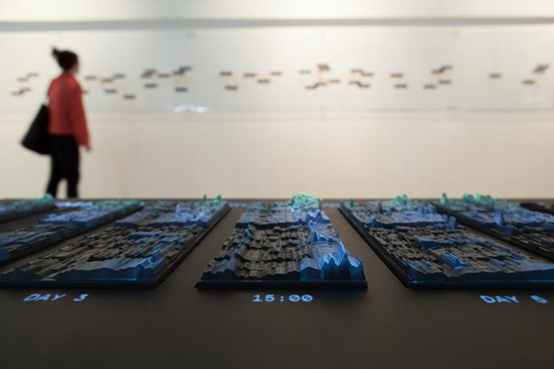

Figure . Emoto: Visualizing the global response at the London 2012 Olympic Games on Twitter

Except the purpose of home surveillance, there are other reasons for deploying sensors around the house. Research study around home system is another reason. Jennifer Beaudin and Stephen Intille described the problems and solution they found when using ubiquitous sensors for data collection in real homes [4]. Their core kit contained a thin wire reed switch, a magnet and a storage board with coin battery, which was fixed with physically manipulated object around house to record the actions. Additionally, they also included infrared beacons on the ceiling to detect the position of the user who wear a receiver. This paper defined problems around such tool kit for study purpose, such as the visibility, attachability, the installation and so on.

Self-reflection is another important issue around the activity tracking topic. This issue of how technology should be designed to support people’s reflection has been raised and discussed [5]. Most of reflection and awareness technology in HCI have been focused on affective system, which reflect the emotion and feeling, such as EmoteMail [6], affective diary [7], or Affector [8]. There are also discussion and researches related to reflection of body physiology, movement and behaviors. For example, Enhancing Self-Reflection with Wearable Sensors [9], Personal Informatics in the Wild: Hacking Habits for Health & Happiness [10], And Footprint Tracker [11]. However rare research mentioned the reflection about the house. Combining the surveillance system and data visualization to contribute the reflection of our home, could be an interesting and valuable topic.

We are considering visualizing the home data in physical form. There are various physical forms presenting periodical data to emphasize the reflection. The studio NAND has presented EMOTO, which use 3D physical data sculpture to visualize the global response around the London 2012 Olympic Games on Twitter [Figure 2]. In other work, Laurie Frick demonstrates her daily activities and nightly sleep data with 2D ink and watercolor drawing [Figure 1]. And the Physical Visualization website [http://dataphys.org/list/] also shows a list of physical data visualization examples.

On the whole, we realize that discussion related home surveillance system less focused on the expressions of its data, which however have rise a reasonable research interest.

# Proposed solution

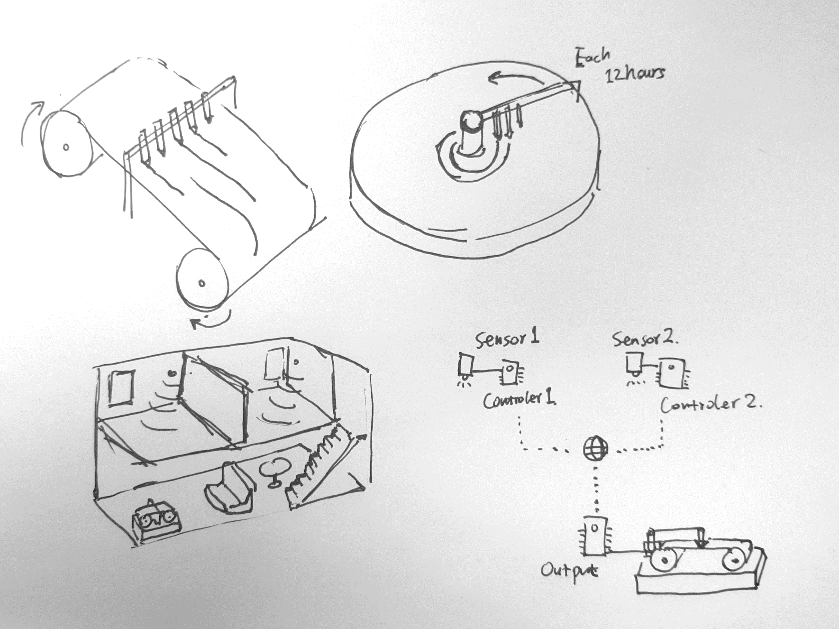Our group believes that based on what we have learned in this course, it is possible to build a system which collects one or several types of data from sensors, then records and presents the data with a less intrusive output. We think users can benefit from looking at this output to learn more about what has happened recently. As pet owners can check how was their pet doing along at home; tenants can check how the public space and utilities are used; families can share more detailed information with each other and know deeper about the house. Since the data is transmitted through the internet, when the sensors separate from the output, users might able to see the status of their house or share it with other people.

Figure . The design of the system (below) and the drawing output (above)

# Proposed Implementation

As Figure 3 shows, we are thinking about using several internet-enabled micro-controllers with sensors to monitor the house and send the data to a central micro-controller which controls the output system. The output system is in charge of visualizing the data under timely order. As we are inspired by the electrocardiograph device, our current design it to build the output system with several colored pens controlled individually moving on a roll of paper or a plate of paper. Other materials will be considered if possible. If pen heads are moving in a circular motion, it might be also used as a wall clock, which the hour hand is drawn on the paper with colors. But this will require users to change the clock face paper each 12 hours after on circle is completed. Otherwise, if the paper is going from one roll to another, the drawing can be kept longer than a day.

Currently, we are going to attach micro solenoids to a 3D printed arm which controls the movement of color pens. A set of gears will be set for moving either this arm or the paper base under a timed order. Based on our last project, the motor and the control board are capable of providing strong torque in a very low speed. We also have gained experience on controlling multiple magnets with integrated circuit. The basic moving mechanism can be either close to the [Linear Clock](http://www.instructables.com/id/Linear-Clock/) or the [Arduino clock v.2.0](http://www.instructables.com/id/Arduino-clock-v20/). We will determine the best implementation based on our project’s need. Since this system is designed to work indoor at home, it should be better working with Wi-Fi enabled microcontroller. We plan to keep using Particle Photon because it is small and we have learned a lot about how to develop program on this platform. The data collection will be accomplished with a sensor such like the [PIR Motion Sensor](https://www.sparkfun.com/products/13285) for sparkfun.com, a Photon, a power source such like a Lithium Ion Battery and some serve circut. Using the cloud service, the Photon in the output system can easily subscribe multiple information source from other Photons.

We are still discussing and finding a better way of implementing our concept, more interaction might be added if time permits.

# Project progress

## Initial Solution

Our group believes that based on what we have learned in this course, it is possible to build a system which collects one or several types of data from sensors, then records and presents the data with a less intrusive output. We think users can benefit from looking at this output to learn more about what has happened recently. For example, pet owners can check how was their pet doing along at home; tenants can check how the public space and utilities are used; families can share more detailed information with each other and know deeper about the house. Since the data is transmitted through the internet, when the sensors separate from the output, users might able to see the status of their house or share it with other people.

## Design

We spent many time on discussing the possible ways to implement our initial concept. Although using pen+paper might be an easy answer, this solution has two significant drawbacks: user have to change the consumable writing material, both paper and the ink; and it is hard to incorporate with on-the market pens with our motors and gears, which might lead to an unstable physical system.

Thus, we started to consider self-erasable material, such like sand or plasticine. To fulfill our system design requirement, multiple data source should be able to be visualized with quantitative representation. A sandbox will not have the accuracy we need, unless it is very big and have many different kinds of sand. We did a simple test on the plasticine idea with some Play-Doh.We found that it might require high pressure and complicated settings to use mechanical method to erase the mark on plasticine. Softer plasticine material can dry out within several days, because they use water as the dispersant. However, the oil-based plasticine is harder in texture.

In the end, we decide to use acrylic bricks as the information indicator. To connect the time will the data, the acrylic bricks will be mounted on a clock surface, and the entire output device will be able to work like a clock.

# Implementation

## Software:

There are three sections in software Part of project implementation - clock basic operation, push acrylic according received data, data source. The first segment to implement clock basic operation. Instead of making two step motor move continuously for 24 hours, we are pushing it to move specific angle periodically -- hour plate moves 6 degrees every 12 minutes, and minute plate move 6 degrees every minute. There are two main reasons for this change. First is to avoid the error in calculation of moving speed of step motor (step motor is more accurate in move specific angle). The second reason is to corporate with the movement of acrylic. Since we control the servo to push acrylic brick in the vertical direction of hour plate, to decrease the fraction between movement of hour plate and movable acrylic, the hour plate need to stop when servo push the movable acrylic. Another important aspect of clock operation is the steps number for step motor each time. In order to lower error of angle, that step motor run each time, the motor need to move integer steps. Since we are using the 4096 step motor, which means a full circle takes 4096 step, this condition also constrains the number of gears (calculation seeing below). Considering we are both running minute plate and hour plate, as mentioned before, every 12 minutes the minute plate and hour plate will run at the same time. To achieve this, multiple threads are applied in this case. One thread is for the minute plate moving, another thread is for the hour plate and servo running.

In the second segments, sensors send data to the main Photon (which run step motors and servos) every 30 second. Photon will calculate the average of data in 12 minute, and push the servo to move the acrylic brick after step motor finish turning. To augment the visualization of data, the height of movable acrylic (which is controlled by the servo) need to fit to the range of data. For example, the temperature data which got from the web, only set to the range of usual temperature. There is another hardware issue comes with running two servos with photon. Since the voltage provided by the photon is not enough to support two servos, we tried to run it with additional 5-volt battery. However, the outcome is unstable. To define the problem, we tested signal to serve with an oscilloscope. It is shown the noise in the signal, which come with the battery. Instead of using extra battery, we used the USB to get the power source.

For the data source, for now we are using light sensors, motion detector (from Amazon: http://www.amazon.com/gp/product/B013LA6MW0?psc=1&redirect=true&ref_=oh_aui_detailpage_o00_s00) and temperature data from the web (http://openweathermap.org/api). Due to the needs of time adjustment, every time flashes the code into a photon, user need to reset the clock from the serial port

## Hardware

To make the clock, we built our design on the Illustrator file for the laser cutter. In last project we noticed that the print time of the 3D printer is too long that it might slow down the prototyping process. So in this project we are more willing to use the laser cutter to make the parts we need. If the size of certain part needs adjustment, we can do it easily on the laser cutter Illustrator file. After the cutting file was made, we made a wooden model for the proof of concept (Figure 5). Since we want to save the expensive acrylic board we brought, the acrylic was not used until most of the parts have been proved to be in the right size. During the testing, we want the acrylic brick and the hole fit as close as possible, maintaining a smooth but also tight movement. In order to achieve that, we cut holes with tiny difference on the length and width (Figure 7). After this test I was able to draw the design file with just right amount of space for the servos to push the bricks (Figure 4, 6).

We found a website called “Gear Generator” to make the gear pattern we need in this project. After we learned about the step motor’s behavior, we calculated that the bigger gear plate for minute and hour display should have 15*n teeth, and the smaller gear on the motor should have 2n number of teeth. This will keep the rotating plate stop every 6 degrees with no error. (For each minute, the minute plate should turn 6 degrees.)

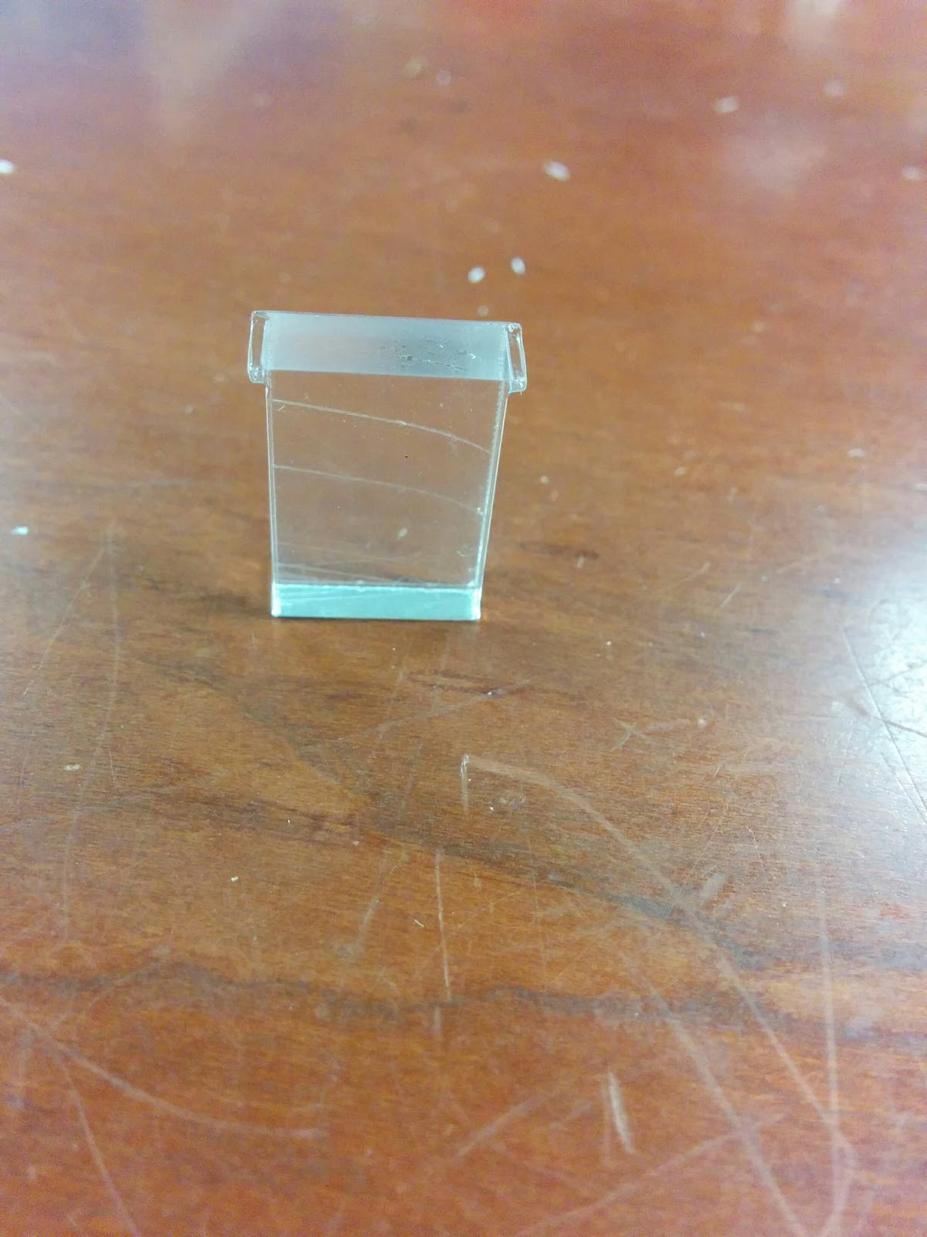

Figure 4. The acrylic brick

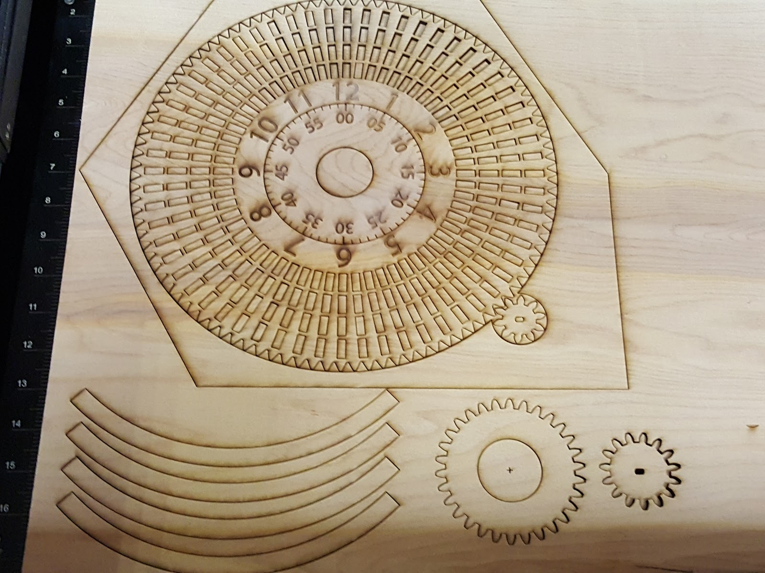

Figure 5. The wooden test

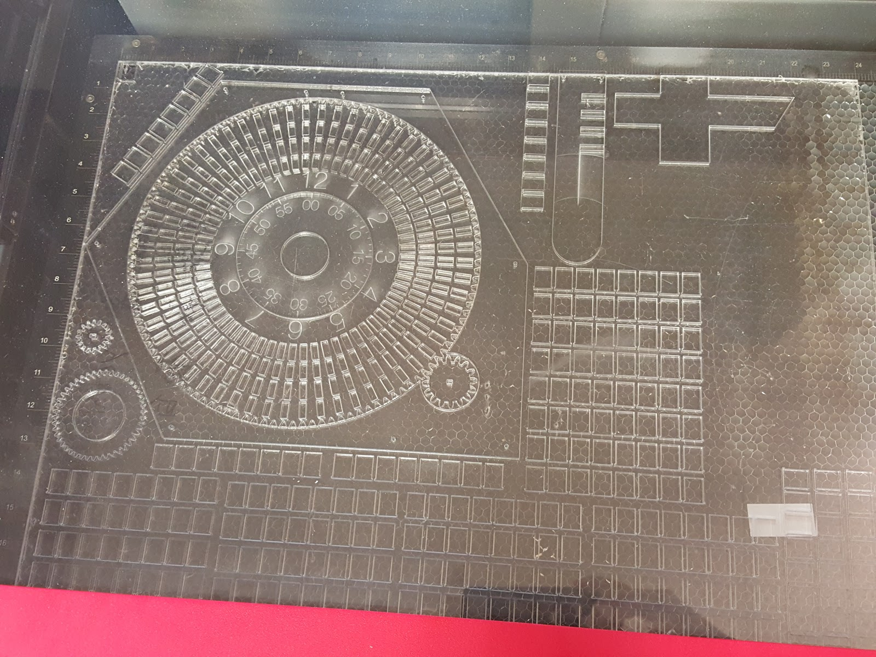

Figure 6. The finial acrylic board

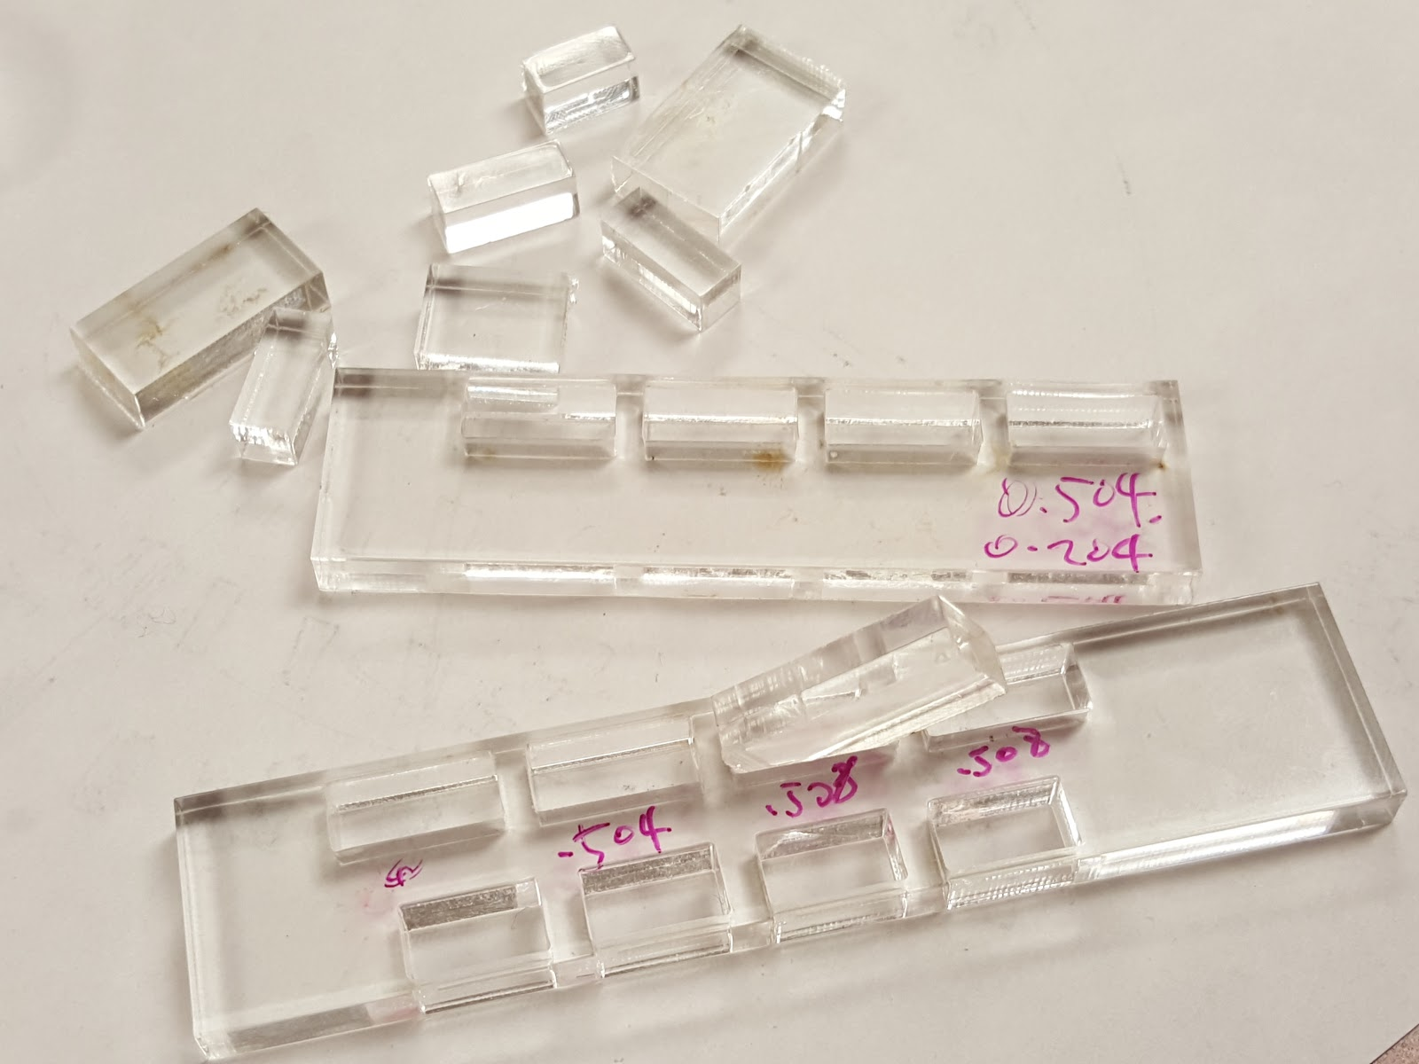

Figure 7. Test for the cutting width

In the assembly, we used many glue instead of screws and bolts. This saved us some efforts in the design process, but once the glue is cured, we won’t be able to do any adjustment.

The finial result is a half-success, since in the design there should be damping grease to work as the support, lubrication and stick the brick in the position until being pushed. But we didn’t able to find the right damping grease in time neither online nor locally. We believe that if we have the grease, this output device will able to work properly.

# Lesson Learned and discussion

If we have more acrylic and wood board for the testing, we might able to make the test easier. Because we can make the prototype one at a time.

While doing a hardware + software combined debugging, oscilloscope is a wonderful tool to see whether the problem is coming from the software or the hardware. It also can help us identify what can be the possible problem through the signal transmitting.

For software part, self-adaptive data might be an important functionality to consider in future implementation. For example, the temperature data have different range between summer and winter. If we choose a large range to contain temperature both in summer and winter, the visualization of daily temperature change might not be obvious. It is better for device to change the temperature range periodically based on recent records.

It’s also interesting to know, how users will understand and translate data from this clock. For example, how many information might be the maximum for user to perceive? Which data representation most user would prefer, adaptive or fixed? How user will combine different data together to reflect their house status? All the question will influence the design to better fit users need.

# References

1. Choe, E. K., Consolvo, S., Jung, J., Harrison, B., & Kientz, J. A. (2011). Living in a Glass House: A Survey of Private Moments in the Home. In Proceedings of the 13th International Conference on Ubiquitous Computing (pp. 41–44). New York, NY, USA: ACM. http://doi.org/10.1145/2030112.2030118
2. Luo, R. C., Yih, C.-C., & Su, K. L. (2002). Multisensor fusion and integration: approaches, applications, and future research directions. IEEE Sensors Journal, 2(2), 107–119. http://doi.org/10.1109/JSEN.2002.1000251
3. Sivaram, G. S. V. S., Kankanhalli, M. S., & Ramakrishnan, K. R. (2009). Design of Multimedia Surveillance Systems. ACM Trans. Multimedia Comput. Commun. Appl., 5(3), 23:1–23:25. http://doi.org/10.1145/1556134.1556140
4. Beaudin, J., Intille, S., & Tapia, E. M. (2004). Lessons Learned Using Ubiquitous Sensors for Data Collection in Real Homes. In CHI ’04 Extended Abstracts on Human Factors in Computing Systems (pp. 1359–1362). New York, NY, USA: ACM.http://doi.org/10.1145/985921.986064
5. Sas, C., & Dix, A. (2009). Designing for Reflection on Experience. In CHI ’09 Extended Abstracts on Human Factors in Computing Systems (pp. 4741–4744). New York, NY, USA: ACM.http://doi.org/10.1145/1520340.1520730
6. Ängeslevä, J., Reynolds, C., & O’Modhrain, S. (2004). EmoteMail. In ACM SIGGRAPH 2004 Posters (p. 9–). New York, NY, USA: ACM.http://doi.org/10.1145/1186415.1186426
7. Lindström, M., St\a ahl, A., Höök, K., Sundström, P., Laaksolathi, J., Combetto, M., … Bresin, R. (2006). Affective Diary: Designing for Bodily Expressiveness and Self-reflection. In CHI ’06 Extended Abstracts on Human Factors in Computing Systems (pp. 1037–1042). New York, NY, USA: ACM.http://doi.org/10.1145/1125451.1125649
8. Boehner, K., DePaula, R., Dourish, P., & Sengers, P. (2005). Affect: From Information to Interaction. In Proceedings of the 4th Decennial Conference on Critical Computing: Between Sense and Sensibility (pp. 59–68). New York, NY, USA: ACM.http://doi.org/10.1145/1094562.1094570
9. Kefalidou, G., Skatova, A., Brown, M., Shipp, V., Pinchin, J., Kelly, P., … Sun, X. (2014). Enhancing Self-reflection with Wearable Sensors. In Proceedings of the 16th International Conference on Human-computer Interaction with Mobile Devices & Services (pp. 577–580). New York, NY, USA: ACM.http://doi.org/10.1145/2628363.2634257
10. Li, I., Froehlich, J., Larsen, J. E., Grevet, C., & Ramirez, E. (2013). Personal Informatics in the Wild: Hacking Habits for Health & Happiness. In CHI ’13 Extended Abstracts on Human Factors in Computing Systems (pp. 3179–3182). New York, NY, USA: ACM.http://doi.org/10.1145/2468356.2479641
11. Gouveia, R., & Karapanos, E. (2013). Footprint Tracker: Supporting Diary Studies with Lifelogging. In Proceedings of the SIGCHI Conference on Human Factors in Computing Systems (pp. 2921–2930). New York, NY, USA: ACM.http://doi.org/10.1145/2470654.2481405